Task 1)
#include <iostream>
using namespace std;
struct Employee
{
char name[50];
int age;
float basicsalary;
float grosssalary;

void inputbasicsalary(Employee *ptr1)
{
cout <<"Enter name:" <<endl;
cin.ignore();
cin.getline(ptr1->name,50);
cout <<"Enter basic salary:" <<endl;
cin>>ptr1-> basicsalary;

}
void calculate(Employee *ptr1)
{

grosssalary = (0.1*basicsalary)+ (0.15*basicsalary)+ (0.7*basicsalary)+ (0.25*basicsalary);

}
void displayresult(Employee *ptr1)
{
cout << "Name :" << name<<endl;
cout << "Gross salary: " << grosssalary <<endl;
}
};
int main()
{

Employee *ptr; // pehla question
Employee obj1,obj2,obj3,obj4,obj5;
ptr = &obj1;
cout << "Person 1:" << endl;
ptr->inputbasicsalary(ptr);// pointer bhej raha hoon
ptr->calculate(ptr);
ptr->displayresult(ptr);
cout <<"Person 2:" <<endl;
ptr = &obj2;
ptr->inputbasicsalary(ptr);
ptr->calculate(ptr);
ptr->displayresult(ptr);
cout << "Person 3:" << endl;
ptr = &obj3;
ptr->inputbasicsalary(ptr);
ptr->calculate(ptr);
ptr->displayresult(ptr);
cout << "Person 4:" << endl;
ptr = &obj4;
ptr->inputbasicsalary(ptr);
ptr->calculate(ptr);
ptr->displayresult(ptr);
cout << "Person 5:" << endl;
ptr = &obj5;
ptr->inputbasicsalary(ptr);
ptr->calculate(ptr);
ptr->displayresult(ptr);

system("pause");
}
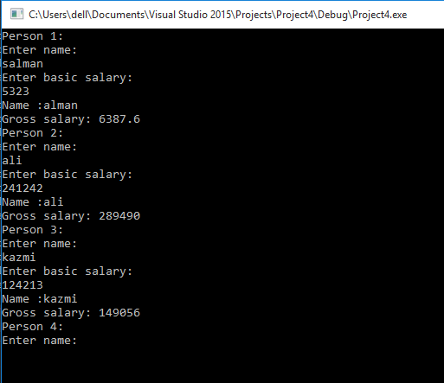
Task 2)
#include <iostream>
using namespace std;
struct Employee
{
char name[50];
int age;
float basicsalary;
float grosssalary;// was not initilize
friend void inputbasicsalary(Employee* ptr1);
friend void calculate(Employee* ptr1);
friend void displayresult(Employee* ptr1);
};
void inputbasicsalary(Employee* ptr1)
{
cout << "Enter name:" << endl;
cin.getline(ptr1->name, 50);
cout << "Enter basic salary:" << endl;
cin >> ptr1->basicsalary;
cin.ignore();//THsi is the right place upper ye name ka pahla letter ura rha tha
}
void calculate(Employee* ptr1)
{// ptr1-> was not used with data members then ther cannt be called without ptr1
ptr1->grosssalary = (0.1 * ptr1->basicsalary) + (0.15 * ptr1->basicsalary) + (0.7 * ptr1->basicsalary) + (0.25 * ptr1->basicsalary);
}

void displayresult(Employee* ptr1)
{
cout << "Name :" << ptr1->name << endl;
cout << "Gross salary: " << ptr1->grosssalary << endl;
}
int main()
{

Employee* ptr; // pehla question
Employee obj1, obj2, obj3, obj4, obj5;
ptr = &obj1;
cout << "Person 1:" << endl;
inputbasicsalary(ptr);// pointer bhej raha hoon
calculate(ptr);
displayresult(ptr);
cout << "Person 2:" << endl;
ptr = &obj2;
inputbasicsalary(ptr);
calculate(ptr);
displayresult(ptr);
cout << "Person 3:" << endl;
ptr = &obj3;
inputbasicsalary(ptr);
calculate(ptr);
displayresult(ptr);
cout << "Person 4:" << endl;
ptr = &obj4;
inputbasicsalary(ptr);
calculate(ptr);
displayresult(ptr);
cout << "Person 5:" << endl;
ptr = &obj5;
inputbasicsalary(ptr);
calculate(ptr);
displayresult(ptr);

system("pause");
}
Output:
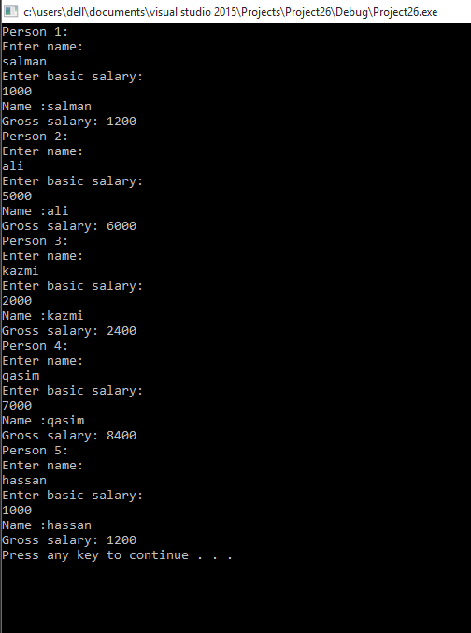
Task 3:
#include <iostream>
using namespace std;
void adddiognals(int **ptr, int **ptr2, int x, int y)
{
int *ptr3 = new int[x];
for (int i = 0; i < x; i++)
{
for (int j = 0; j < y; j++)
{
if (i == j)
{
ptr3[i] = ptr[i][j] + ptr2[i][j];
}

}
}
cout << "Sum of Right Diagonals:" << endl;
cout << "[";
for (int i = 0; i < x; i++)
{
cout << ptr3[i] << ", ";
}
cout << "]";
}
int main()
{
int x, y;
cout << "1st 2d array:" << endl;
cout << "Enter rows :" << endl;
cin >> x;
int **ptr1 = new int*[x];
cout << "Enter columns :" << endl;
cin >> y;
for (int i = 0; i < x; i++)
{
ptr1[i] = new int[y];
}
cout << "Enter elements in matrix 1: " << endl;
for (int i = 0; i <x; i++)
{
for (int j = 0; j <y; j++)
{
cout << endl;
cin >> ptr1[i][j];

}
}
int x2, y2;
cout << "1st 2d array:" << endl;
cout << "Enter rows :" << endl;
cin >> x2;
int **ptr2 = new int*[x2];
cout << "Enter columns :" << endl;
cin >> y2;
for (int i = 0; i < x2; i++)
{
ptr2[i] = new int[y2];
}
cout << "Enter elements in matrix 2: " << endl;
for (int i = 0; i <x2; i++)
{
for (int j = 0; j <y2; j++)
{
cout << endl;
cin >> ptr2[i][j];

}
}
adddiognals(ptr1, ptr2, x, y);
system("pause");

}
Output:

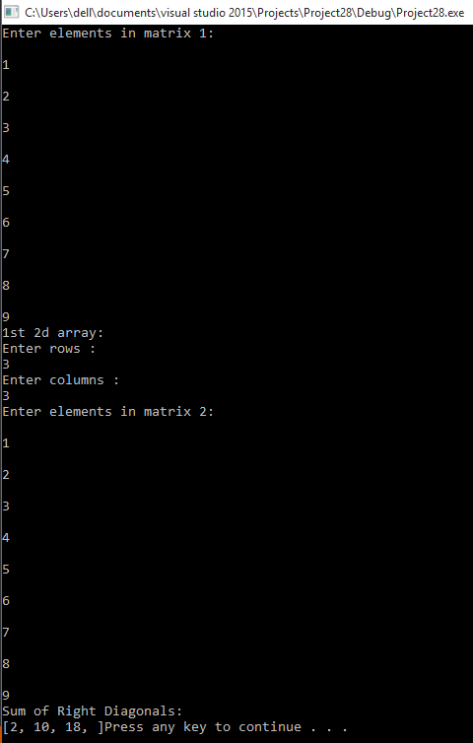
Task 4)
#include <iostream>
using namespace std;
void adddiognals(int **ptr, int **ptr2, int x, int y)
{
int *ptr3 = new int[x];
for (int i = 0; i < x; i++)
{
for (int j = 0; j < y; j++)
{
if ((i+j)==2)
{
ptr3[i] = ptr[i][j] + ptr2[i][j];
}

}
}
cout << "Sum of Left Diagonals:" << endl;
cout << "[";
for (int i = 0; i < x; i++)
{
cout << ptr3[i] << ", ";
}
cout << "]";
}
int main()
{
int x, y;
cout << "1st 2d array:" << endl;
cout << "Enter rows :" << endl;
cin >> x;
int **ptr1 = new int*[x];
cout << "Enter columns :" << endl;
cin >> y;
for (int i = 0; i < x; i++)
{
ptr1[i] = new int[y];
}
cout << "Enter elements in matrix 1: " << endl;
for (int i = 0; i <x; i++)
{
for (int j = 0; j <y; j++)
{
cout << endl;
cin >> ptr1[i][j];

}
}
int x2, y2;
cout << "1st 2d array:" << endl;
cout << "Enter rows :" << endl;
cin >> x2;
int **ptr2 = new int*[x2];
cout << "Enter columns :" << endl;
cin >> y2;
for (int i = 0; i < x2; i++)
{
ptr2[i] = new int[y2];
}
cout << "Enter elements in matrix 2: " << endl;
for (int i = 0; i <x2; i++)
{
for (int j = 0; j <y2; j++)
{
cout << endl;
cin >> ptr2[i][j];

}
}
adddiognals(ptr1, ptr2, x, y);
system("pause");

}
Out put:
